HuaweiCloud Penetration Test Report



Huawei Cloud Computing Company Security Professional Service Delivery Team
Copyright infringement must be prosecuted

Project start and end time: | 2023 / 09 / 01 --- 2023 / 09 / 30

1 Overview 3
1.1 Project Background 3
1.2 Project Plan 3
1.3 Test Scope 3
2 Test Policy 3
2.1 Test Method 3
2.2 Summary of Key Test Points 3
2.3 Test Method Summary 6
2.4 Test Tool Description 6
2.5 Vulnerability Level Definition 7
3 Test Result 8
3.1 Test Result Summary 8
4 Test Result Description 8
4.1 Unauthorized Access to etcd in the Kubernetes Cluster (Medium-risk) 8
4.2 IAM has a URL open redirection vulnerability. (Low-risk) 10
4.3 OpenStack ironic-python-agent Information Leakage Vulnerability (Low-risk) 11
5 Security Suggestions 13
5.1 Vulnerability fixing suggestions 13
5.1.1 Consider "surface" security during vulnerability fixing. 13
5.2 Suggestions for Security Protection 13
5.2.1 Network isolation 13
5.3 Suggestions on Security O&M 13
5.3.1 Security Management Suggestions 13

Overview

Project Background
The purpose of this penetration test is to identify the vulnerability and risk of the assets of management plane of Saudi Arabia NEOM HCSO, and provide the report including the issues and mitigation suggestion.

Project Plan
Test object | Network devices, Servers, and Applications in the NEOM HCSO Management plane
Authorized Test Time | 2023 / 09 / 01 --- 2023 / 09 / 30
Project Leader | Zhang Zhipeng

Test Scope
No. | Network | IP Address
1 | iBMC Plane | 28.249.128.0/17
2 | Service plane | 26.249.128.0/17

Test Policy

Test Method
This penetration test uses the gray-box test method, after connecting to the O&M network via SVN, test the network devices, servers, and also the services and applications are deployed in the management plane.

Summary of Key Test Points
The following table lists the test contents.
Server Evaluation Item | Test Content
Network and Port Detection | Multiple service systems may be deployed on the server of the tested system, or the default service ports may be listened, or even a service within the authorization scope may have exploitable vulnerabilities that affect the tested application system.
Testing the Fingerprint Information of the HTTP Service | 1) Execute the tool, such as the wappalyzer, input the domain name (or IP address) and port number, and click Execute to view the output.  2) We can also use the NC to submit the request and determine the content based on the returned HTTP header.
Multifactor authentication | Check whether multiple authentication modes are used on the login page.
Session Management | Whether the session management mechanism is used; Whether the session cookie has the Http-Only attribute; Check whether the session cookie has the Secure attribute. Indicates whether defend against session hijacking attacks.
Data Verification | Check if there are SQL injection vulnerabilities, XSS vulnerabilities, CSRF cross-site request forgery vulnerabilities, file upload vulnerabilities, command execution vulnerabilities, local verification bypass vulnerabilities, and other vulnerabilities caused by improper data verification.
Use SSL to encrypt sensitive information. | Check whether the pages for sensitive information transmission are encrypted using SSL. The login process uses HTTPS to HTTPS with POST.
Sensitive information protection | Check whether local sensitive information is encrypted during transmission and storage. Check whether the server error information contains sensitive information. Check whether the HTML, JS, and CSS files contain sensitive information. Check whether information leakage occurs during the use of each function.
Configuration management | Indicates whether the server can list directory risks. Check whether the server has directory guessing risks. Check whether the server has the default server management login page. Check whether the HTTP methods, such as OPTIONS, Trace, PUT, and Move, are enabled on the server. Check whether backup files and database files exist in the accessible directory on the server. Check whether the access restriction mechanism is provided for sensitive directories on the server. Check whether there are other risks related to configuration management.
Searching and Utilizing the Console of WEB Server | Search the Web middleware console to find exploitable security vulnerabilities. Enter the URL of the web server in the address box of the browser and check whether the web server console exists. If yes, use the default account and password to log in to the console and check whether the login is successful. If yes, the vulnerability exists.
Open source application version testing | Many websites use open source programs, or are customized on the basis of open source programs, or use part of open source programs, which may have public vulnerabilities.
Directory and file brute force cracking | Searches for directories and files that the crawler cannot connect to in dictionary mode.  Enter the target website and select a dictionary file. The tool automatically scans the existing directories and files.
Unauthorized operations | Assume that you have obtained an application low-level user privilege and are trying to access a known administrative URL that is not available on the administrative menu, submit.
OS command execution test | Some pages may need to invoke system commands based on normal reason. You can replace other commands and check whether the commands are executed.
Bypass authentication test. | 1) Direct access to the protected page.  2) Modify the parameters.  3) Session ID prediction.  4) Cookie spoofing.  5) HTML form SQL bypass authentication (universal password).
Weak password cracking | - On the user login page, generate passwords or load a password dictionary to crack system and device accounts by continuously trying user names and passwords.  - Obtain the default accounts and passwords of the system and devices through information collection and attempt to log in to the system and devices.

Test Method Summary
Multiple penetration testing methods, such as port detection, service identification, fingerprint collection, configuration check, vulnerability test, explosion, and replay analysis, are used to test and analyze the assets on the management plane to detect security risks that the system may face, and provide dedicated security improvement suggestions for timely mitigate and control.

Test Tool Description
The following are common tools for penetration testing:
Tool Type | Test Tool Name
Information collection tool | Port and service identification: nmap, nabbu, httpx, kscan
Information collection tool | JS information collection: JSfinder
Catalog Explosion | dirsearch
Vulnerability scanning tool | Nuclei
Password guessing tool | burp Suite community
Script test tool | burp Suite community

Vulnerability Level Definition
In this penetration test, the vulnerability risk level is determined by the CVSS score.
Common Vulnerability Scoring System (CVSS) is an industry standard designed to evaluate the severity of security vulnerabilities. Developed by several leading companies in the communications and computer security fields.
Currently, CVSS 3.0 is used and Base Metric Group is used to score vulnerabilities (or combined vulnerabilities) to reflect the security risks faced by the system. A score of 9-10 is defined as "Critical", 7-8.9 is defined as "High", 4-6.9 is defined as "Medium", 0-3.9 is defined as "Low".
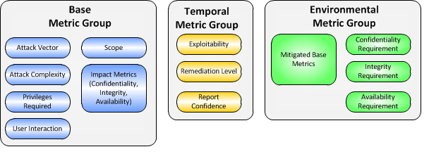
For the vulnerabilities that cannot be directly exploited to threaten the CIA attributes of the system, which do not comply with Huawei's redline definition or security specifications (or best practices in the industry), we will put forward the vulnerabilities in this report. Once the vulnerabilities are exploited, Risks are rated based on the actual risk size. The grading method is based on the CVSS scoring after successful use, Huawei redline definition, and security regulations (or industry best practices).
Critical and major vulnerabilities must be modified, which have a higher priority. It is recommended that the vulnerability at the Minor level be modified. The priority is medium. Warning vulnerabilities can be modified based on the site requirements. However, it is recommended that a long-term rectification plan be made based on the site requirements.

Test Result

Test Result Summary
The penetration test is executed on the platform assets of the management plane. Three types of vulnerabilities are discovered, including one medium-risk vulnerability and two low-risk vulnerabilities. Detailed vulnerability distribution is as follows:
No. | System name | Vulnerability Name | Risk level | Vulnerability Level
1 | 26.249.164.176:2379  26.249.164.175:2379  26.249.164.174:2379 | Unauthorized Access Vulnerability of K8S Cluster etcd | Medium-risk | Level 3
2 | 26.249.164.136 | HCSO IAM has a URL open redirection vulnerability. | Low risk | Level 4
3 | http://26.249.236.6:9999  http://26.249.236.8:9999  http://26.249.220.6:9999  http://26.249.236.5:9999  http://26.249.220.8:9999  http://26.249.220.4:9999  http://26.249.220.5:9999  http://26.249.236.4:9999 | OpenStack ironic-python-agent information leakage vulnerability | Low risk | Level 4

Test Result Description

Unauthorized Access to etcd in the Kubernetes Cluster (Medium-risk)

Test Address
26.249.164.176:2379
26.249.164.175:2379
26.249.164.174:2379

Test Procedure
Run the curl command or ectdctl command to access the ectd API, as shown in.
curl http://26.249.164.176:2379/v2/keys/?recursive?true
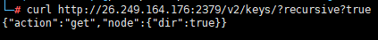
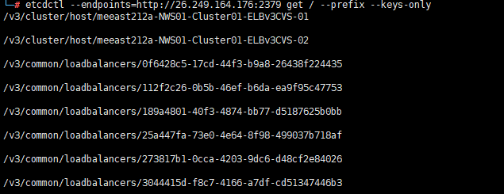
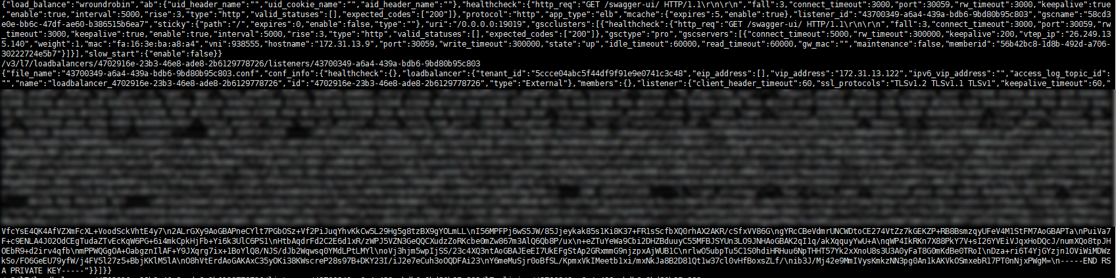

Vulnerability Risk
Kubernetes etcd is used to store data. Unauthorized access to etcd can cause attackers to obtain Kubernetes authentication tokens and keys from etcd and take over the Kubernetes cluster.

Vulnerability Fix suggestion
- When the Etcd is started, the client-cert-auth parameter is used to enable certificate verification.
- etcd data is encrypted for storage, ensuring that etcd data cannot be used after it is leaked.
- Set the listen-client-urls parameter correctly to prevent the service address from being exposed to the external network.

IAM has a URL open redirection vulnerability. (Low-risk)

Test Address
https://26.249.164.136

Test Procedure
Access the login interface and modify the idp_login_url parameter. As a result, the user is redirected to a malicious website.
https://26.249.164.136/authui/federation/login?idp_login_url=http://w3.huawei.com/next/indexa.html&logintoken=1
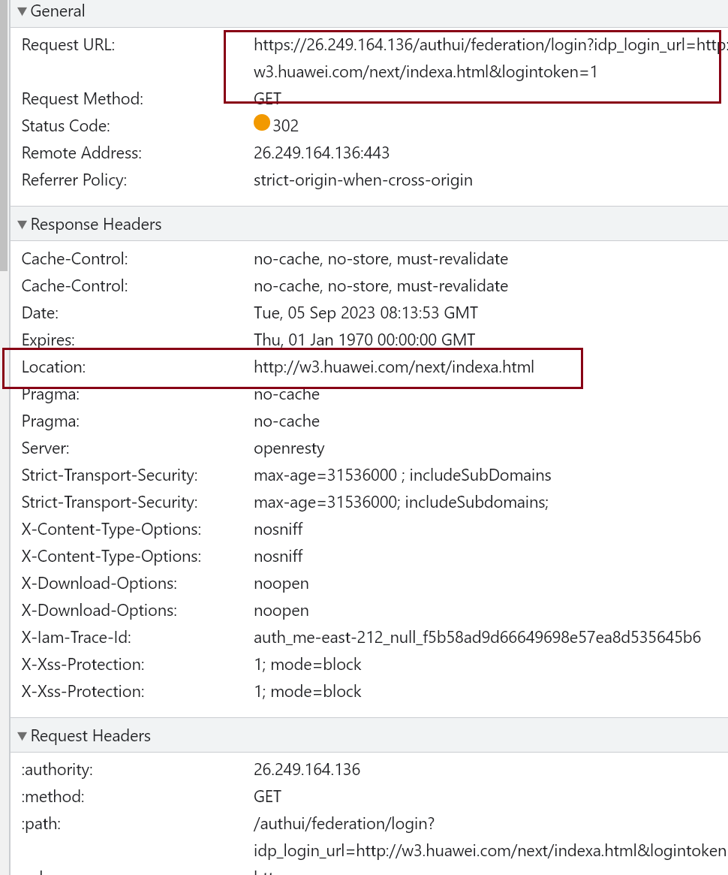

Vulnerability Risk
The root cause of this vulnerability is that the access URLs are not fully verified and filtered. As a result, attackers can construct malicious URLs and redirect users to arbitrary websites or applications to launch phishing attacks, spread malware, and targeted attacks.

Vulnerability Fix suggestion
- Verify and filter the URL parameters to ensure that they are in the expected format and type.
- Define the trustlist of redirected URLs.
- Use a relative or absolute path to avoid using parameters provided by users to directly construct redirection URLs.

OpenStack ironic-python-agent Information Leakage Vulnerability (Low-risk)

Test Address
http://26.249.236.6:9999
http://26.249.236.8:9999
http://26.249.220.6:9999
http://26.249.236.5:9999
http://26.249.220.8:9999
http://26.249.220.4:9999
http://26.249.220.5:9999
http://26.249.236.4:9999

Test Procedure
Accessing an API in a browser
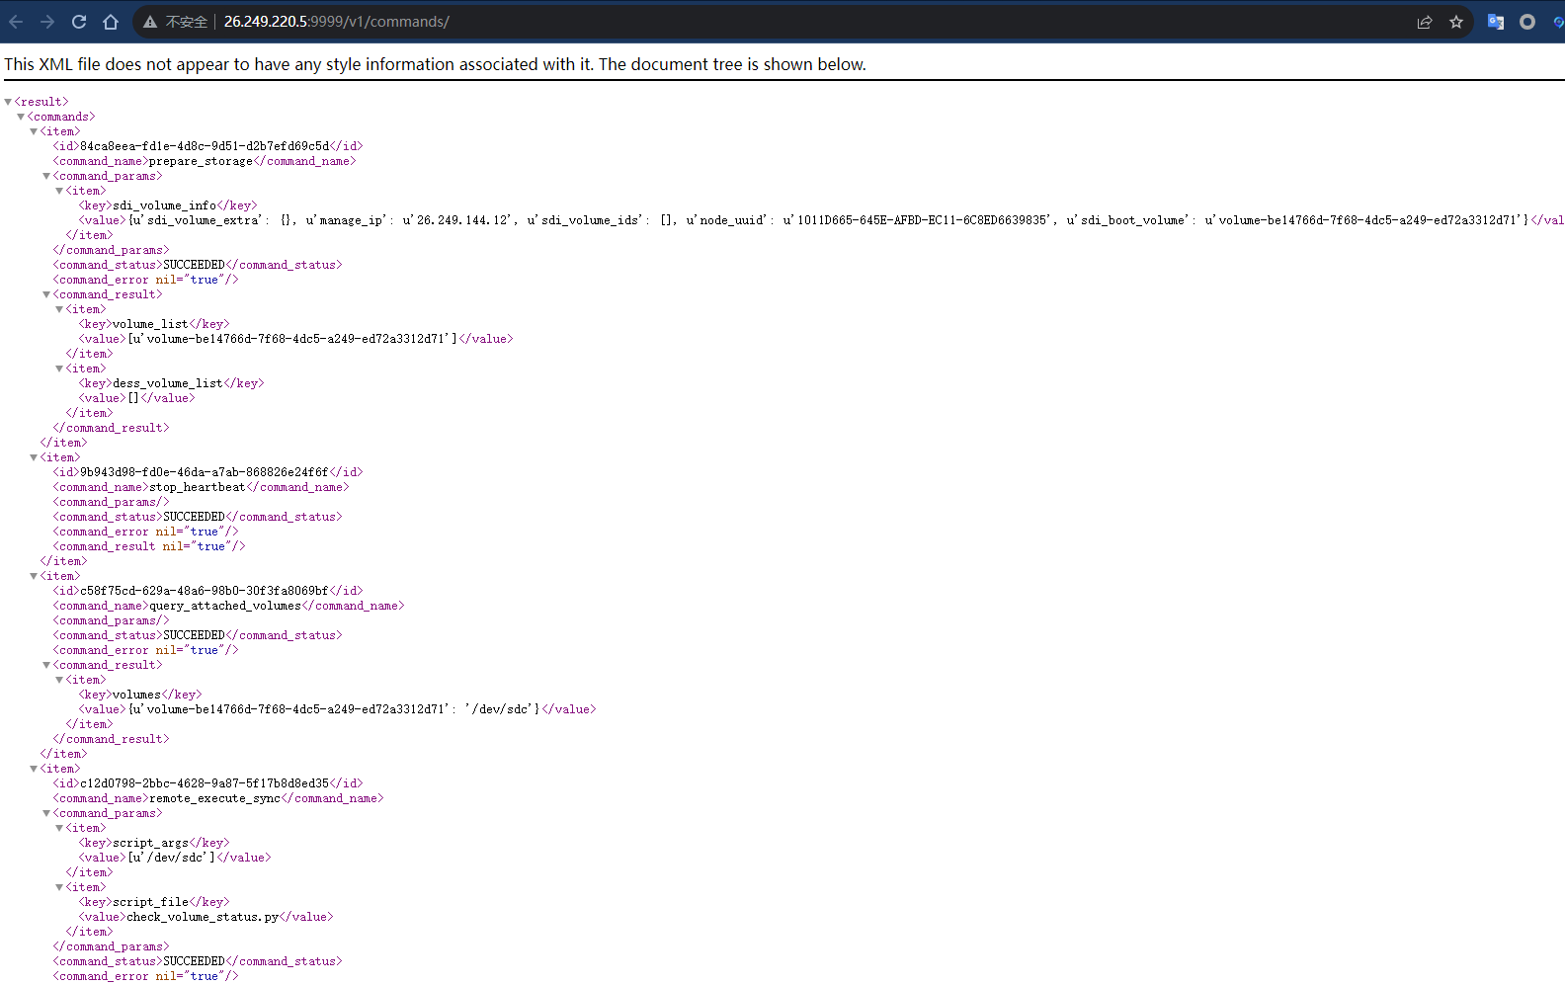
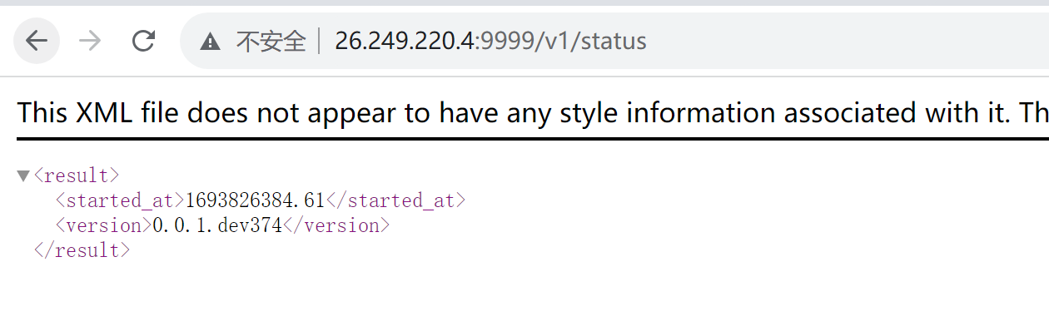

Vulnerability Risk
Service data or internal sensitive information may be disclosed. Some data may be used by attackers to execute system commands and operating system files, causing system damage or major data leakage threats.

Vulnerability Fix suggestion
- Configuring identity authentication and authorization mechanisms for interface access
- Configure the firewall policy to restrict the access of the specified IP address to the interface.

Security Suggestions

Vulnerability fixing suggestions

Consider "surface" security during vulnerability fixing.
Penetration testing may only detect "point" security. For attacks, only a few "point" attacks are required to threaten core assets. For defense, "plane" security must be achieved. When fixing vulnerabilities, consider the whole situation. Don't just fix the security risk of the "point".

Suggestions for Security Protection

Network isolation
- As an independent region, the HCSO may belong to different customers. If the HCSO is an independent region (for example, me-east-212 for NEOM in Saudi Arabia), the O&M zones of different HCSOs are isolated by firewalls at the network layer.

Suggestions on Security O&M

Security Management Suggestions
- For the vulnerabilities found in the penetration test, check whether the coverage scope of the site rollout check and routine vulnerability scanning is missing and whether the corresponding vulnerability detection capabilities and tools need to be supplemented.

